**IST 659 Database Management System**

**Project Implementation Report**

Database Management System in Warehouses

**Prepared By:**

Ayyappa Bhuma [SUID: 258426982

Pranav Sharma [264584180]

Sreelakshmy Cheruvally [387397629]

**CONTENTS**

**Project Summary**

1.Abstract

2.Problem

3.Business Problem

4.Solution

**Potential Entities**

**Business Rules**

**Conceptual Model**

**Logical Model**

**Data Dictionaries**

**SQL Codes**

**Data Logic Questions**

**PROJECT SUMMARY**

**Abstract**

Product availability is a vital part of customer satisfaction. Unavailability of a product leads to the dissatisfaction of the customer which eventually affects the retail business financially. To compete and to stay ahead in the market it is necessary that retailers have their products delivered on time and available for their customers. To ensure this, it is necessary that businesses streamline their goods and services in a timely and in an orderly manner. So, for effective management from the raw material to the final delivery of the product it is necessary that the data be logged appropriately. When a product is about to get over in a shop the shop requires to notify the warehouse about the unavailability. This in turn would check if the warehouse have the products in stock or if they have get them manufactured. Having all those data logged properly and making it available for shops, carriers retailers etc… would make the whole process easier.

**Problem**

In the wake of the pandemic Covid-19, logistics was also one amongst the worst affected industries. Due to lockdown people started shifting from bigger cities to either their hometowns or smaller towns. The flow of supply and demand was completely disrupted. Cities started having lower demand and smaller towns started having more demand compared to how it was before. The total industry faced an imbalance with respect to the supply and demand.

**Business Problem**

Understand the demand of products in different regions and eventually help retailers to improve their business objectives.

**Solution**

Proposing a database management system to keep a track on the product availability both in store and warehouses. This tracking is useful both for companies who are supplying to the shops and for customers to know what items are available in which shops.

**Potential Entities**

1.Areas

Attributes:

* Name of the area of shop or warehouse
* Address of the particular shop or warehouse

2.Warehouses

Attributes:

* Name of the warehouse
* Name of the area
* Zip code

3.Shops

Attributes:

* Name of the shop
* Name of the area
* Zip code

4.Items

Attributes:

* Name

5.Shipment

Attributes:

* Quantity of the item shipped
* Status of the shipment

6.Shop Item availability

* Item Quantity

7.Warehouse Item availability

* Item Quantity

**Business Rules**

1. An area can have zero or one warehouse. A warehouse can have only one area.
2. An area can have zero or more shops. A shop can have only one area.
3. A warehouse ships zero or more shipments. A shipment is shipped from only one warehouse.
4. A shop is shipped by zero or more shipments. A shipment is shipped to only one store.
5. Items are available at warehouse item availability. Warehouse Item availability is availed by items.
6. Items are available at shop item availability. Shop Item availability is availed by items.
7. The warehouse id is a unique set of numbers required to identify the warehouses
8. The area zip code is unique as it denotes the area where the shops and warehouses are situated
9. Shops have an unique shop_id which helps in identification of the shops during shipment of products
10. It is mandatory for all items to have an unique item_id since it is with this id items are checked for their availability in shops, warehouses and also while shipment.
11. To track the shipment entries it is necessary to have a unique shipment_id for shipments. This also helps in tracking from the start to the delivery.
12. Warehouse_item_availability is the unique id which gives the details of the availability of items in the warehouse.
13. Shop_item_availability is the unique id which gives the details of the availability of items in the shop.

**Conceptual Model**

**Logical Model**

**Data Dictionaries**

**SQL Codes**

**Creating Tables and Constraints**

--DOWN

drop table if EXISTS area

GO

--UP

create table area(

    area_id INTEGER IDENTITY not  null,

    area_name varchar(50) not null,

    city varchar(50) not null,

    state varchar(50) not null,

    zip_code INTEGER not null

    CONSTRAINT pk_area_2 PRIMARY KEY (zip_code)

   )

GO

--DOWN

drop table if EXISTS warehouse

go

--UP

create table warehouse (

    warehouse_id INTEGER identity not null,

    warehouse_name varchar (50) not null,

    area_name VARCHAR (50) not null,

    area_zip_code INTEGER not null,

    contact VARCHAR (50) not NULL

    CONSTRAINT pk_warehouse_2 PRIMARY KEY (warehouse_id)

  --  CONSTRAINT fk_warehouse FOREIGN KEY area_zip_code REFERENCES area (zip_code)

)

ALTER TABLE warehouse ADD CONSTRAINT fk_warehouse_2 FOREIGN KEY (area_zip_code) REFERENCES area (zip_code)

GO

--DOWN

drop table if EXISTS shops

Go

--UP

create table shops(

    shop_id INTEGER identity not NULL,

    shop_name VARCHAR (50) not NULL,

    area_name VARCHAR (50) not NULL,

    area_zip_code INTEGER not NULL,

    CONSTRAINT pk_shops_2 PRIMARY KEY (shop_id)

   -- CONSTRAINT fk_shops FOREIGN KEY (area_zip_code)  REFERENCES area (zip_code)

)

alter table shops add CONSTRAINT fk_shops FOREIGN KEY (area_zip_code) REFERENCES area (zip_code)

--DOWN

drop table if EXISTS items

GO

--UP

create table items(

    item_id INTEGER identity not NULL,

    item_name VARCHAR(50) not null,

    CONSTRAINT pk_item_2 PRIMARY KEY (item_id)

)

--DOWN

drop table if exists warehouse_item_availability

GO

--UP

create table warehouse_item_availability(

    warehouse_item_availability_id INTEGER IDENTITY NOT NULL,

    warehouse_id INTEGER  not null,

    item_id INTEGER not NULL,

    item_quantity NUMERIC,

    CONSTRAINT pk_warehouse_item_availability_id PRIMARY KEY(warehouse_item_availability_id),

    CONSTRAINT fk_warehouse_item_availability_2  FOREIGN KEY (warehouse_id) REFERENCES warehouse(warehouse_id),

    CONSTRAINT fk_item_id_2 FOREIGN KEY (item_id) REFERENCES items(item_id)

)

--DOWN

drop table  if exists  shop_item_availability

GO

--UP

create table shop_item_availability (

    shop_item_availability_id INTEGER IDENTITY NOT NULL,

    shop_id INTEGER not NULL,

    item_id INTEGER not NULL,

    item_quantity NUMERIC,

    CONSTRAINT pk_shop_item_availability_id PRIMARY KEY (shop_item_availability_id),

    CONSTRAINT fk_shop_id FOREIGN KEY (shop_id) REFERENCES shops(shop_id),

    CONSTRAINT fk_item_id FOREIGN KEY (item_id) REFERENCES items(item_id)

)

--DOWN

drop table if EXISTS shipment

--UP

create table shipment(

    shipment_id INTEGER identity NOT NULL,

    warehouse_id INTEGER NOT NULL,

    shop_id INTEGER NOT NULL,

    item_in_shipment_id INTEGER NOT NULL,

    item_quantity_in_shipment NUMERIC NOT NULL,

    is_delivered CHAR(1),

    CONSTRAINT pk_shipment_id PRIMARY KEY (shipment_id)

)

ALTER table shipment add CONSTRAINT fk_shipment_warehouse_id FOREIGN KEY (warehouse_id) REFERENCES warehouse(warehouse_id)

ALTER table shipment add CONSTRAINT fk_shipment_shop_id FOREIGN KEY (shop_id) REFERENCES shops(shop_id)

ALTER table shipment add CONSTRAINT fk_shipment_item_id FOREIGN KEY (item_in_shipment_id) REFERENCES items(item_id)

GO

--DOWN

drop view if EXISTS warehouse_shop_same_area_list

GO

--UP

create view warehouse_shop_same_area_list as

select w.warehouse_name, sh.shop_name from warehouse w join shops sh on w.area_zip_code = sh.area_zip_code

go

**Insert Queries**

1. **Warehouse - 40 lines**

INSERT INTO warehouse(warehouse_name,area_name,area_zip_code) VALUES ('Worldwide Material Handling','Prattsville',12468)

INSERT INTO warehouse(warehouse_name,area_name,area_zip_code) VALUES ('Blue Logistics','Brownville',13615)

INSERT INTO warehouse(warehouse_name,area_name,area_zip_code) VALUES ('Eastern Warehouses','Elizabethtown',12932)

INSERT INTO warehouse(warehouse_name,area_name,area_zip_code) VALUES ('HWC Logistics','Flushing',11351)

INSERT INTO warehouse(warehouse_name,area_name,area_zip_code) VALUES ('Shipping-and-Handling.com','Sidney',13838)

INSERT INTO warehouse(warehouse_name,area_name,area_zip_code) VALUES ('Aspen Distribution','Northville',12134)

INSERT INTO warehouse(warehouse_name,area_name,area_zip_code) VALUES ('Cardinal Publishers Group','Brentwood',11717)

INSERT INTO warehouse(warehouse_name,area_name,area_zip_code) VALUES ('Piedmont Moving Systems','Hunter',12442)

INSERT INTO warehouse(warehouse_name,area_name,area_zip_code) VALUES ('Safeway Logistics','Schenectady',12301)

INSERT INTO warehouse(warehouse_name,area_name,area_zip_code) VALUES ('J&J Distributing','Congers',10920)

INSERT INTO warehouse(warehouse_name,area_name,area_zip_code) VALUES ('El Valle Relocation Services','Farmingdale',11737)

INSERT INTO warehouse(warehouse_name,area_name,area_zip_code) VALUES ('Jillamy','Billings',12510)

INSERT INTO warehouse(warehouse_name,area_name,area_zip_code) VALUES ('Murphy Warehouse','Huntington',11743)

INSERT INTO warehouse(warehouse_name,area_name,area_zip_code) VALUES ('FMG','Cicero',13039)

INSERT INTO warehouse(warehouse_name,area_name,area_zip_code) VALUES ('Neill Cartage','Brainard',12024)

INSERT INTO warehouse(warehouse_name,area_name,area_zip_code) VALUES ('FLEXE','Marlboro',12542)

INSERT INTO warehouse(warehouse_name,area_name,area_zip_code) VALUES ('Co-op Partners Warehouse','Flushing',11352)

INSERT INTO warehouse(warehouse_name,area_name,area_zip_code) VALUES ('Merchants Transfer','Stottville',12172)

INSERT INTO warehouse(warehouse_name,area_name,area_zip_code) VALUES ('Amware','Lynbrook',11563)

INSERT INTO warehouse(warehouse_name,area_name,area_zip_code) VALUES ('Bonded Logistics','Durhamville',13054)

INSERT INTO warehouse(warehouse_name,area_name,area_zip_code) VALUES ('Verde Fulfillment USA','Alplaus',12008)

INSERT INTO warehouse(warehouse_name,area_name,area_zip_code) VALUES ('FW Logistics','Queensbury',12804)

INSERT INTO warehouse(warehouse_name,area_name,area_zip_code) VALUES ('Laney Duke','Ilion',13357)

INSERT INTO warehouse(warehouse_name,area_name,area_zip_code) VALUES ('Overflo Warehouse','Melville',11775)

INSERT INTO warehouse(warehouse_name,area_name,area_zip_code) VALUES ('Columbian Logistics Network','Cropseyville',12052)

INSERT INTO warehouse(warehouse_name,area_name,area_zip_code) VALUES ('Morrison Industrial Equipment','Unionville',10988)

INSERT INTO warehouse(warehouse_name,area_name,area_zip_code) VALUES ('Hopkins Distribution','Woodridge',12789)

INSERT INTO warehouse(warehouse_name,area_name,area_zip_code) VALUES ('TDR Logistics','Albany',12205)

INSERT INTO warehouse(warehouse_name,area_name,area_zip_code) VALUES ('Nebraska Warehouse','Waterloo',13165)

INSERT INTO warehouse(warehouse_name,area_name,area_zip_code) VALUES ('MilwaukeeWarehouse','Albany',12250)

INSERT INTO warehouse(warehouse_name,area_name,area_zip_code) VALUES ('National Commercial Warehouse','Maplecrest',12454)

INSERT INTO warehouse(warehouse_name,area_name,area_zip_code) VALUES ('Phoenix Warehouse','Melville',11747)

INSERT INTO warehouse(warehouse_name,area_name,area_zip_code) VALUES ('Harbor Distributing','Brooklyn',11238)

INSERT INTO warehouse(warehouse_name,area_name,area_zip_code) VALUES ('Lindner Logistics','Syracuse',13225)

INSERT INTO warehouse(warehouse_name,area_name,area_zip_code) VALUES ('Xtreme Cartage & Warehousing','Rensselaerville',12147)

INSERT INTO warehouse(warehouse_name,area_name,area_zip_code) VALUES ('American Warehouse','Columbiaville',12050)

INSERT INTO warehouse(warehouse_name,area_name,area_zip_code) VALUES ('Jrc Dedicated Services Co','Kingston',12402)

INSERT INTO warehouse(warehouse_name,area_name,area_zip_code) VALUES ('Lineage Logistics','Nelliston',13410)

INSERT INTO warehouse(warehouse_name,area_name,area_zip_code) VALUES ('Group Warehouses','Southampton',11969)

1. **Items- 50 lines**

INSERT INTO items (item_name) VALUES ('HAND WARMER UNION JACK')

INSERT INTO items (item_name) VALUES ('ASSORTED COLOUR BIRD ORNAMENT')

INSERT INTO items (item_name) VALUES ('JAM MAKING SET WITH JARS')

INSERT INTO items (item_name) VALUES ('BATH BUILDING BLOCK WORD')

INSERT INTO items (item_name) VALUES ('ALARM CLOCK BAKELIKE PINK')

INSERT INTO items (item_name) VALUES ('PAPER CHAIN KIT 50s CHRISTMAS ')

INSERT INTO items (item_name) VALUES ('HAND WARMER RED POLKA DOT')

INSERT INTO items (item_name) VALUES ('VICTORIAN SEWING BOX LARGE')

INSERT INTO items (item_name) VALUES ('HOT WATER BOTTLE TEA AND SYMPATHY')

INSERT INTO items (item_name) VALUES ('JUMBO BAG PINK POLKADOT')

INSERT INTO items (item_name) VALUES ('JAM MAKING SET PRINTED')

INSERT INTO items (item_name) VALUES ('RETROSPOT TEA SET CERAMIC 11 PC ')

INSERT INTO items (item_name) VALUES ('INFLATABLE POLITICAL GLOBE ')

INSERT INTO items (item_name) VALUES ('WOOD BLACK BOARD ANT WHITE FINISH')

INSERT INTO items (item_name) VALUES ('SET 3 WICKER OVAL BASKETS W LIDS')

INSERT INTO items (item_name) VALUES ('WHITE WIRE EGG HOLDER')

INSERT INTO items (item_name) VALUES ('CHILLI LIGHTS')

INSERT INTO items (item_name) VALUES ('HOME BUILDING BLOCK WORD')

INSERT INTO items (item_name) VALUES ('CHRISTMAS LIGHTS 10 REINDEER')

INSERT INTO items (item_name) VALUES ('3 STRIPEY MICE FELTCRAFT')

INSERT INTO items (item_name) VALUES ('RETROSPOT LAMP')

INSERT INTO items (item_name) VALUES ('FANCY FONT BIRTHDAY CARD, ')

INSERT INTO items (item_name) VALUES ('BLACK HEART CARD HOLDER')

INSERT INTO items (item_name) VALUES ('PACK OF 12 RED RETROSPOT TISSUES ')

INSERT INTO items (item_name) VALUES ('HOMEMADE JAM SCENTED CANDLES')

INSERT INTO items (item_name) VALUES ('BIRD HOUSE HOT WATER BOTTLE')

INSERT INTO items (item_name) VALUES ('HAND WARMER BIRD DESIGN')

INSERT INTO items (item_name) VALUES ('HEART IVORY TRELLIS SMALL')

INSERT INTO items (item_name) VALUES ('SET/5 RED RETROSPOT LID GLASS BOWLS')

INSERT INTO items (item_name) VALUES ('MAGIC DRAWING SLATE DINOSAUR')

INSERT INTO items (item_name) VALUES ('LUNCH BAG CARS BLUE')

INSERT INTO items (item_name) VALUES ('60 CAKE CASES VINTAGE CHRISTMAS')

INSERT INTO items (item_name) VALUES ('ROTATING LEAVES T-LIGHT HOLDER')

INSERT INTO items (item_name) VALUES ('WOODEN BOX OF DOMINOES')

INSERT INTO items (item_name) VALUES ('SET OF 6 SOLDIER SKITTLES')

INSERT INTO items (item_name) VALUES ('HOT WATER BOTTLE BABUSHKA ')

INSERT INTO items (item_name) VALUES ('RED RETROSPOT OVEN GLOVE ')

INSERT INTO items (item_name) VALUES ('HYACINTH BULB T-LIGHT CANDLES')

INSERT INTO items (item_name) VALUES ('FRENCH WC SIGN BLUE METAL')

INSERT INTO items (item_name) VALUES ('WASHROOM METAL SIGN')

INSERT INTO items (item_name) VALUES ('SMALL GLASS HEART TRINKET POT')

INSERT INTO items (item_name) VALUES ('RIBBON REEL SNOWY VILLAGE')

INSERT INTO items (item_name) VALUES ('VINTAGE UNION JACK CUSHION COVER')

INSERT INTO items (item_name) VALUES ('ANTIQUE SILVER TEA GLASS ENGRAVED')

INSERT INTO items (item_name) VALUES ('HAND WARMER OWL DESIGN')

INSERT INTO items (item_name) VALUES ('CLASSIC FRENCH STYLE BASKET NATURAL')

INSERT INTO items (item_name) VALUES ('CREAM SWEETHEART EGG HOLDER')

INSERT INTO items (item_name) VALUES ('CHRISTMAS LIGHTS 10 VINTAGE BAUBLES')

INSERT INTO items (item_name) VALUES ('SWISS ROLL TOWEL, CHOCOLATE  SPOTS')

INSERT INTO items (item_name) VALUES ('EIGHT PIECE DINOSAUR SET')

1. Shops - 65 lines

INSERT INTO shops (shop_name,area_name,area_zip_code) VALUES('Bargain Hunt','Chappaqua',10514)

INSERT INTO shops (shop_name,area_name,area_zip_code) VALUES('Ben Franklin','Plessis',13675)

INSERT INTO shops (shop_name,area_name,area_zip_code) VALUES('Big Lots','Stamford',12167)

INSERT INTO shops (shop_name,area_name,area_zip_code) VALUES('Bi-Mart','Pawling',12564)

INSERT INTO shops (shop_name,area_name,area_zip_code) VALUES('BJs Wholesale Club','Syosset',11791)

INSERT INTO shops (shop_name,area_name,area_zip_code) VALUES('Boyds','Cutchogue',11935)

INSERT INTO shops (shop_name,area_name,area_zip_code) VALUES('Burlington','Hicksville',11854)

INSERT INTO shops (shop_name,area_name,area_zip_code) VALUES('Christmas Tree Shops','Hillsdale',12529)

INSERT INTO shops (shop_name,area_name,area_zip_code) VALUES('Costco','Valatie',12184)

INSERT INTO shops (shop_name,area_name,area_zip_code) VALUES('David M. Brian','Babylon',11702)

INSERT INTO shops (shop_name,area_name,area_zip_code) VALUES('Dds Discounts','Phillipsport',12769)

INSERT INTO shops (shop_name,area_name,area_zip_code) VALUES('Dirt Cheap','Albany',12255)

INSERT INTO shops (shop_name,area_name,area_zip_code) VALUES('Dollar General','Congers',10920)

INSERT INTO shops (shop_name,area_name,area_zip_code) VALUES('Dollar Tree','Carlisle',12031)

INSERT INTO shops (shop_name,area_name,area_zip_code) VALUES('Dunhams Department Store','Hartwick',13348)

INSERT INTO shops (shop_name,area_name,area_zip_code) VALUES('Family Dollar','Wantagh',11793)

INSERT INTO shops (shop_name,area_name,area_zip_code) VALUES('Five Below','Glenmont',12077)

INSERT INTO shops (shop_name,area_name,area_zip_code) VALUES('Flemington Department Store','Jamaica',11433)

INSERT INTO shops (shop_name,area_name,area_zip_code) VALUES('Fords Federated Store','Nelliston',13410)

INSERT INTO shops (shop_name,area_name,area_zip_code) VALUES('Fred Meyer','Maryknoll',10545)

INSERT INTO shops (shop_name,area_name,area_zip_code) VALUES('Gabes','Schenectady',12304)

INSERT INTO shops (shop_name,area_name,area_zip_code) VALUES('Getz"s','Calverton',11933)

INSERT INTO shops (shop_name,area_name,area_zip_code) VALUES('Gus Mayer','Peru',12972)

INSERT INTO shops (shop_name,area_name,area_zip_code) VALUES('Halls','Woodridge',12789)

INSERT INTO shops (shop_name,area_name,area_zip_code) VALUES('Harbor Freight Tools','Schenectady',12301)

INSERT INTO shops (shop_name,area_name,area_zip_code) VALUES('HomeGoods','Latham',12110)

INSERT INTO shops (shop_name,area_name,area_zip_code) VALUES('HomeSense','Delmar',12054)

INSERT INTO shops (shop_name,area_name,area_zip_code) VALUES('Jos. Kuhn & Co.','Watervliet',12189)

INSERT INTO shops (shop_name,area_name,area_zip_code) VALUES('Kraus Department Store','Harris',12742)

INSERT INTO shops (shop_name,area_name,area_zip_code) VALUES('La Epoca','Utica',13599)

INSERT INTO shops (shop_name,area_name,area_zip_code) VALUES('LaVogue Department Store','Irvington',10533)

INSERT INTO shops (shop_name,area_name,area_zip_code) VALUES('Leader Department Store','Columbiaville',12050)

INSERT INTO shops (shop_name,area_name,area_zip_code) VALUES('Loeb"s','Pelham',10803)

INSERT INTO shops (shop_name,area_name,area_zip_code) VALUES('Mack & Dave"s Department Store','Rome',13442)

INSERT INTO shops (shop_name,area_name,area_zip_code) VALUES('Marshalls','Montauk',11954)

INSERT INTO shops (shop_name,area_name,area_zip_code) VALUES('McCaulou"s Department Store','Westernville',13486)

INSERT INTO shops (shop_name,area_name,area_zip_code) VALUES('Meijer','Newburgh',12551)

INSERT INTO shops (shop_name,area_name,area_zip_code) VALUES('Murphy"s','Cropseyville',12052)

INSERT INTO shops (shop_name,area_name,area_zip_code) VALUES('National Stores','Waterloo',13165)

INSERT INTO shops (shop_name,area_name,area_zip_code) VALUES('Neighborhood Goods','Brentwood',11717)

INSERT INTO shops (shop_name,area_name,area_zip_code) VALUES('Neilson"s','Florida',10921)

INSERT INTO shops (shop_name,area_name,area_zip_code) VALUES('Nichols Stores','Phoenix',13135)

INSERT INTO shops (shop_name,area_name,area_zip_code) VALUES('Ocean State Job Lot','Syracuse',13203)

INSERT INTO shops (shop_name,area_name,area_zip_code) VALUES('Ollie"s Bargain Outlet','Nyack',10960)

INSERT INTO shops (shop_name,area_name,area_zip_code) VALUES('Reed"s','Cottekill',12419)

INSERT INTO shops (shop_name,area_name,area_zip_code) VALUES('Renys','Rhinecliff',12574)

INSERT INTO shops (shop_name,area_name,area_zip_code) VALUES('Roses','Brownville',13615)

INSERT INTO shops (shop_name,area_name,area_zip_code) VALUES('Ross Stores','Deansboro',13328)

INSERT INTO shops (shop_name,area_name,area_zip_code) VALUES('Ruben"s','Barrytown',12507)

INSERT INTO shops (shop_name,area_name,area_zip_code) VALUES('Rubensteins','Ellisburg',13636)

INSERT INTO shops (shop_name,area_name,area_zip_code) VALUES('Sam"s Club','Auburn',13021)

INSERT INTO shops (shop_name,area_name,area_zip_code) VALUES('Schroeder"s','Berlin',12022)

INSERT INTO shops (shop_name,area_name,area_zip_code) VALUES('Scott Seale"s','Orient',11957)

INSERT INTO shops (shop_name,area_name,area_zip_code) VALUES('Shirokiya','Poughkeepsie',12601)

INSERT INTO shops (shop_name,area_name,area_zip_code) VALUES('Stahlke"s','Maplecrest',12454)

INSERT INTO shops (shop_name,area_name,area_zip_code) VALUES('Stanley Korshak','Nedrow',13120)

INSERT INTO shops (shop_name,area_name,area_zip_code) VALUES('T.J. Maxx','Elizabethtown',12932)

INSERT INTO shops (shop_name,area_name,area_zip_code) VALUES('Target','Genoa',13071)

INSERT INTO shops (shop_name,area_name,area_zip_code) VALUES('The SM Store','Marlboro',12542)

INSERT INTO shops (shop_name,area_name,area_zip_code) VALUES('Tomah Cash Mercantile','Brooklyn',11203)

INSERT INTO shops (shop_name,area_name,area_zip_code) VALUES('Treasure Hunt','Stottville',12172)

INSERT INTO shops (shop_name,area_name,area_zip_code) VALUES('Tuesday Morning','Surprise',12176)

INSERT INTO shops (shop_name,area_name,area_zip_code) VALUES('Wakefield"s','Brewerton',13029)

INSERT INTO shops (shop_name,area_name,area_zip_code) VALUES('Walmart','Hague',12836)

INSERT INTO shops (shop_name,area_name,area_zip_code) VALUES('Weaver"s','Hewlett',11557)

INSERT INTO shops (shop_name,area_name,area_zip_code) VALUES('Young"s Department Store','Carmel',10512)

1. **Warehouse item availability -- 126 lines**

INSERT INTO warehouse_item_availability (warehouse_id,item_id,item_quantity) VALUES(40,1,3)

INSERT INTO warehouse_item_availability (warehouse_id,item_id,item_quantity) VALUES(41,2,7)

INSERT INTO warehouse_item_availability (warehouse_id,item_id,item_quantity) VALUES(42,3,2)

INSERT INTO warehouse_item_availability (warehouse_id,item_id,item_quantity) VALUES(43,4,14)

INSERT INTO warehouse_item_availability (warehouse_id,item_id,item_quantity) VALUES(44,5,5)

INSERT INTO warehouse_item_availability (warehouse_id,item_id,item_quantity) VALUES(45,6,3)

INSERT INTO warehouse_item_availability (warehouse_id,item_id,item_quantity) VALUES(46,7,1)

INSERT INTO warehouse_item_availability (warehouse_id,item_id,item_quantity) VALUES(47,8,10)

INSERT INTO warehouse_item_availability (warehouse_id,item_id,item_quantity) VALUES(48,9,13)

INSERT INTO warehouse_item_availability (warehouse_id,item_id,item_quantity) VALUES(49,10,11)

INSERT INTO warehouse_item_availability (warehouse_id,item_id,item_quantity) VALUES(50,11,13)

INSERT INTO warehouse_item_availability (warehouse_id,item_id,item_quantity) VALUES(51,12,10)

INSERT INTO warehouse_item_availability (warehouse_id,item_id,item_quantity) VALUES(52,13,18)

INSERT INTO warehouse_item_availability (warehouse_id,item_id,item_quantity) VALUES(53,14,7)

INSERT INTO warehouse_item_availability (warehouse_id,item_id,item_quantity) VALUES(54,15,16)

INSERT INTO warehouse_item_availability (warehouse_id,item_id,item_quantity) VALUES(55,16,15)

INSERT INTO warehouse_item_availability (warehouse_id,item_id,item_quantity) VALUES(56,17,6)

INSERT INTO warehouse_item_availability (warehouse_id,item_id,item_quantity) VALUES(57,18,3)

INSERT INTO warehouse_item_availability (warehouse_id,item_id,item_quantity) VALUES(58,19,2)

INSERT INTO warehouse_item_availability (warehouse_id,item_id,item_quantity) VALUES(59,20,3)

INSERT INTO warehouse_item_availability (warehouse_id,item_id,item_quantity) VALUES(60,21,12)

INSERT INTO warehouse_item_availability (warehouse_id,item_id,item_quantity) VALUES(61,22,15)

INSERT INTO warehouse_item_availability (warehouse_id,item_id,item_quantity) VALUES(62,23,14)

INSERT INTO warehouse_item_availability (warehouse_id,item_id,item_quantity) VALUES(63,24,11)

INSERT INTO warehouse_item_availability (warehouse_id,item_id,item_quantity) VALUES(64,25,8)

INSERT INTO warehouse_item_availability (warehouse_id,item_id,item_quantity) VALUES(65,26,7)

INSERT INTO warehouse_item_availability (warehouse_id,item_id,item_quantity) VALUES(66,27,17)

INSERT INTO warehouse_item_availability (warehouse_id,item_id,item_quantity) VALUES(67,28,19)

INSERT INTO warehouse_item_availability (warehouse_id,item_id,item_quantity) VALUES(68,29,5)

INSERT INTO warehouse_item_availability (warehouse_id,item_id,item_quantity) VALUES(69,30,5)

INSERT INTO warehouse_item_availability (warehouse_id,item_id,item_quantity) VALUES(70,31,8)

INSERT INTO warehouse_item_availability (warehouse_id,item_id,item_quantity) VALUES(71,32,11)

INSERT INTO warehouse_item_availability (warehouse_id,item_id,item_quantity) VALUES(72,33,7)

INSERT INTO warehouse_item_availability (warehouse_id,item_id,item_quantity) VALUES(73,34,9)

INSERT INTO warehouse_item_availability (warehouse_id,item_id,item_quantity) VALUES(74,35,4)

INSERT INTO warehouse_item_availability (warehouse_id,item_id,item_quantity) VALUES(75,36,7)

INSERT INTO warehouse_item_availability (warehouse_id,item_id,item_quantity) VALUES(76,37,8)

INSERT INTO warehouse_item_availability (warehouse_id,item_id,item_quantity) VALUES(77,38,14)

INSERT INTO warehouse_item_availability (warehouse_id,item_id,item_quantity) VALUES(78,39,14)

INSERT INTO warehouse_item_availability (warehouse_id,item_id,item_quantity) VALUES(40,40,1)

INSERT INTO warehouse_item_availability (warehouse_id,item_id,item_quantity) VALUES(41,41,4)

INSERT INTO warehouse_item_availability (warehouse_id,item_id,item_quantity) VALUES(42,42,13)

INSERT INTO warehouse_item_availability (warehouse_id,item_id,item_quantity) VALUES(43,43,12)

INSERT INTO warehouse_item_availability (warehouse_id,item_id,item_quantity) VALUES(44,44,13)

INSERT INTO warehouse_item_availability (warehouse_id,item_id,item_quantity) VALUES(45,45,14)

INSERT INTO warehouse_item_availability (warehouse_id,item_id,item_quantity) VALUES(46,46,5)

INSERT INTO warehouse_item_availability (warehouse_id,item_id,item_quantity) VALUES(47,47,2)

INSERT INTO warehouse_item_availability (warehouse_id,item_id,item_quantity) VALUES(48,48,17)

INSERT INTO warehouse_item_availability (warehouse_id,item_id,item_quantity) VALUES(49,49,9)

INSERT INTO warehouse_item_availability (warehouse_id,item_id,item_quantity) VALUES(50,50,2)

INSERT INTO warehouse_item_availability (warehouse_id,item_id,item_quantity) VALUES(51,1,5)

INSERT INTO warehouse_item_availability (warehouse_id,item_id,item_quantity) VALUES(52,2,14)

INSERT INTO warehouse_item_availability (warehouse_id,item_id,item_quantity) VALUES(53,3,11)

INSERT INTO warehouse_item_availability (warehouse_id,item_id,item_quantity) VALUES(54,4,9)

INSERT INTO warehouse_item_availability (warehouse_id,item_id,item_quantity) VALUES(55,5,19)

INSERT INTO warehouse_item_availability (warehouse_id,item_id,item_quantity) VALUES(56,6,3)

INSERT INTO warehouse_item_availability (warehouse_id,item_id,item_quantity) VALUES(57,7,11)

INSERT INTO warehouse_item_availability (warehouse_id,item_id,item_quantity) VALUES(58,8,12)

INSERT INTO warehouse_item_availability (warehouse_id,item_id,item_quantity) VALUES(59,9,10)

INSERT INTO warehouse_item_availability (warehouse_id,item_id,item_quantity) VALUES(60,10,7)

INSERT INTO warehouse_item_availability (warehouse_id,item_id,item_quantity) VALUES(61,11,3)

INSERT INTO warehouse_item_availability (warehouse_id,item_id,item_quantity) VALUES(62,12,4)

INSERT INTO warehouse_item_availability (warehouse_id,item_id,item_quantity) VALUES(63,13,1)

INSERT INTO warehouse_item_availability (warehouse_id,item_id,item_quantity) VALUES(64,14,16)

INSERT INTO warehouse_item_availability (warehouse_id,item_id,item_quantity) VALUES(65,15,2)

INSERT INTO warehouse_item_availability (warehouse_id,item_id,item_quantity) VALUES(66,16,11)

INSERT INTO warehouse_item_availability (warehouse_id,item_id,item_quantity) VALUES(67,17,10)

INSERT INTO warehouse_item_availability (warehouse_id,item_id,item_quantity) VALUES(68,18,13)

INSERT INTO warehouse_item_availability (warehouse_id,item_id,item_quantity) VALUES(69,19,4)

INSERT INTO warehouse_item_availability (warehouse_id,item_id,item_quantity) VALUES(70,20,16)

INSERT INTO warehouse_item_availability (warehouse_id,item_id,item_quantity) VALUES(71,21,14)

INSERT INTO warehouse_item_availability (warehouse_id,item_id,item_quantity) VALUES(72,22,16)

INSERT INTO warehouse_item_availability (warehouse_id,item_id,item_quantity) VALUES(73,23,15)

INSERT INTO warehouse_item_availability (warehouse_id,item_id,item_quantity) VALUES(74,24,17)

INSERT INTO warehouse_item_availability (warehouse_id,item_id,item_quantity) VALUES(75,25,8)

INSERT INTO warehouse_item_availability (warehouse_id,item_id,item_quantity) VALUES(76,26,12)

INSERT INTO warehouse_item_availability (warehouse_id,item_id,item_quantity) VALUES(77,27,5)

INSERT INTO warehouse_item_availability (warehouse_id,item_id,item_quantity) VALUES(78,28,2)

INSERT INTO warehouse_item_availability (warehouse_id,item_id,item_quantity) VALUES(40,29,2)

INSERT INTO warehouse_item_availability (warehouse_id,item_id,item_quantity) VALUES(41,30,12)

INSERT INTO warehouse_item_availability (warehouse_id,item_id,item_quantity) VALUES(42,31,18)

INSERT INTO warehouse_item_availability (warehouse_id,item_id,item_quantity) VALUES(43,32,11)

INSERT INTO warehouse_item_availability (warehouse_id,item_id,item_quantity) VALUES(44,33,13)

INSERT INTO warehouse_item_availability (warehouse_id,item_id,item_quantity) VALUES(45,34,17)

INSERT INTO warehouse_item_availability (warehouse_id,item_id,item_quantity) VALUES(46,35,14)

INSERT INTO warehouse_item_availability (warehouse_id,item_id,item_quantity) VALUES(47,36,6)

INSERT INTO warehouse_item_availability (warehouse_id,item_id,item_quantity) VALUES(48,37,3)

INSERT INTO warehouse_item_availability (warehouse_id,item_id,item_quantity) VALUES(49,38,15)

INSERT INTO warehouse_item_availability (warehouse_id,item_id,item_quantity) VALUES(50,39,10)

INSERT INTO warehouse_item_availability (warehouse_id,item_id,item_quantity) VALUES(51,40,8)

INSERT INTO warehouse_item_availability (warehouse_id,item_id,item_quantity) VALUES(52,41,18)

INSERT INTO warehouse_item_availability (warehouse_id,item_id,item_quantity) VALUES(53,42,12)

INSERT INTO warehouse_item_availability (warehouse_id,item_id,item_quantity) VALUES(54,43,6)

INSERT INTO warehouse_item_availability (warehouse_id,item_id,item_quantity) VALUES(55,44,12)

INSERT INTO warehouse_item_availability (warehouse_id,item_id,item_quantity) VALUES(56,45,3)

INSERT INTO warehouse_item_availability (warehouse_id,item_id,item_quantity) VALUES(57,46,17)

INSERT INTO warehouse_item_availability (warehouse_id,item_id,item_quantity) VALUES(58,47,7)

INSERT INTO warehouse_item_availability (warehouse_id,item_id,item_quantity) VALUES(59,48,14)

INSERT INTO warehouse_item_availability (warehouse_id,item_id,item_quantity) VALUES(60,49,18)

INSERT INTO warehouse_item_availability (warehouse_id,item_id,item_quantity) VALUES(61,50,1)

INSERT INTO warehouse_item_availability (warehouse_id,item_id,item_quantity) VALUES(62,1,10)

INSERT INTO warehouse_item_availability (warehouse_id,item_id,item_quantity) VALUES(63,2,12)

INSERT INTO warehouse_item_availability (warehouse_id,item_id,item_quantity) VALUES(64,3,18)

INSERT INTO warehouse_item_availability (warehouse_id,item_id,item_quantity) VALUES(65,4,13)

INSERT INTO warehouse_item_availability (warehouse_id,item_id,item_quantity) VALUES(66,5,3)

INSERT INTO warehouse_item_availability (warehouse_id,item_id,item_quantity) VALUES(67,6,12)

INSERT INTO warehouse_item_availability (warehouse_id,item_id,item_quantity) VALUES(68,7,11)

INSERT INTO warehouse_item_availability (warehouse_id,item_id,item_quantity) VALUES(69,8,13)

INSERT INTO warehouse_item_availability (warehouse_id,item_id,item_quantity) VALUES(70,9,10)

INSERT INTO warehouse_item_availability (warehouse_id,item_id,item_quantity) VALUES(71,10,19)

INSERT INTO warehouse_item_availability (warehouse_id,item_id,item_quantity) VALUES(72,11,18)

INSERT INTO warehouse_item_availability (warehouse_id,item_id,item_quantity) VALUES(73,12,5)

INSERT INTO warehouse_item_availability (warehouse_id,item_id,item_quantity) VALUES(74,13,7)

INSERT INTO warehouse_item_availability (warehouse_id,item_id,item_quantity) VALUES(75,14,4)

INSERT INTO warehouse_item_availability (warehouse_id,item_id,item_quantity) VALUES(76,15,5)

INSERT INTO warehouse_item_availability (warehouse_id,item_id,item_quantity) VALUES(77,16,6)

INSERT INTO warehouse_item_availability (warehouse_id,item_id,item_quantity) VALUES(78,17,12)

INSERT INTO warehouse_item_availability (warehouse_id,item_id,item_quantity) VALUES(40,18,2)

INSERT INTO warehouse_item_availability (warehouse_id,item_id,item_quantity) VALUES(41,19,3)

INSERT INTO warehouse_item_availability (warehouse_id,item_id,item_quantity) VALUES(42,20,12)

INSERT INTO warehouse_item_availability (warehouse_id,item_id,item_quantity) VALUES(43,21,7)

INSERT INTO warehouse_item_availability (warehouse_id,item_id,item_quantity) VALUES(44,22,12)

INSERT INTO warehouse_item_availability (warehouse_id,item_id,item_quantity) VALUES(45,23,15)

INSERT INTO warehouse_item_availability (warehouse_id,item_id,item_quantity) VALUES(46,24,10)

INSERT INTO warehouse_item_availability (warehouse_id,item_id,item_quantity) VALUES(47,25,1)

INSERT INTO warehouse_item_availability (warehouse_id,item_id,item_quantity) VALUES(48,26,9)

1. **Shop_item_availability**

INSERT INTO shop_item_availability (shop_id,item_id,item_quantity) VALUES ( 1   ,   1   ,   19  )

INSERT INTO shop_item_availability (shop_id,item_id,item_quantity) VALUES ( 2   ,   2   ,   3   )

INSERT INTO shop_item_availability (shop_id,item_id,item_quantity) VALUES ( 3   ,   3   ,   7   )

INSERT INTO shop_item_availability (shop_id,item_id,item_quantity) VALUES ( 4   ,   4   ,   12  )

INSERT INTO shop_item_availability (shop_id,item_id,item_quantity) VALUES ( 5   ,   5   ,   3   )

INSERT INTO shop_item_availability (shop_id,item_id,item_quantity) VALUES ( 6   ,   6   ,   6   )

INSERT INTO shop_item_availability (shop_id,item_id,item_quantity) VALUES ( 7   ,   7   ,   10  )

INSERT INTO shop_item_availability (shop_id,item_id,item_quantity) VALUES ( 8   ,   8   ,   2   )

INSERT INTO shop_item_availability (shop_id,item_id,item_quantity) VALUES ( 9   ,   9   ,   3   )

INSERT INTO shop_item_availability (shop_id,item_id,item_quantity) VALUES ( 10  ,   10  ,   13  )

INSERT INTO shop_item_availability (shop_id,item_id,item_quantity) VALUES ( 11  ,   11  ,   3   )

INSERT INTO shop_item_availability (shop_id,item_id,item_quantity) VALUES ( 12  ,   12  ,   17  )

INSERT INTO shop_item_availability (shop_id,item_id,item_quantity) VALUES ( 13  ,   13  ,   14  )

INSERT INTO shop_item_availability (shop_id,item_id,item_quantity) VALUES ( 14  ,   14  ,   18  )

INSERT INTO shop_item_availability (shop_id,item_id,item_quantity) VALUES ( 15  ,   15  ,   19  )

INSERT INTO shop_item_availability (shop_id,item_id,item_quantity) VALUES ( 16  ,   16  ,   3   )

INSERT INTO shop_item_availability (shop_id,item_id,item_quantity) VALUES ( 17  ,   17  ,   19  )

INSERT INTO shop_item_availability (shop_id,item_id,item_quantity) VALUES ( 18  ,   18  ,   17  )

INSERT INTO shop_item_availability (shop_id,item_id,item_quantity) VALUES ( 19  ,   19  ,   15  )

INSERT INTO shop_item_availability (shop_id,item_id,item_quantity) VALUES ( 20  ,   20  ,   15  )

INSERT INTO shop_item_availability (shop_id,item_id,item_quantity) VALUES ( 21  ,   21  ,   11  )

INSERT INTO shop_item_availability (shop_id,item_id,item_quantity) VALUES ( 22  ,   22  ,   11  )

INSERT INTO shop_item_availability (shop_id,item_id,item_quantity) VALUES ( 23  ,   23  ,   1   )

INSERT INTO shop_item_availability (shop_id,item_id,item_quantity) VALUES ( 24  ,   24  ,   1   )

INSERT INTO shop_item_availability (shop_id,item_id,item_quantity) VALUES ( 25  ,   25  ,   7   )

INSERT INTO shop_item_availability (shop_id,item_id,item_quantity) VALUES ( 26  ,   26  ,   3   )

INSERT INTO shop_item_availability (shop_id,item_id,item_quantity) VALUES ( 27  ,   27  ,   1   )

INSERT INTO shop_item_availability (shop_id,item_id,item_quantity) VALUES ( 28  ,   28  ,   14  )

INSERT INTO shop_item_availability (shop_id,item_id,item_quantity) VALUES ( 29  ,   29  ,   12  )

INSERT INTO shop_item_availability (shop_id,item_id,item_quantity) VALUES ( 30  ,   30  ,   16  )

INSERT INTO shop_item_availability (shop_id,item_id,item_quantity) VALUES ( 31  ,   31  ,   5   )

INSERT INTO shop_item_availability (shop_id,item_id,item_quantity) VALUES ( 32  ,   32  ,   5   )

INSERT INTO shop_item_availability (shop_id,item_id,item_quantity) VALUES ( 33  ,   33  ,   7   )

INSERT INTO shop_item_availability (shop_id,item_id,item_quantity) VALUES ( 34  ,   34  ,   19  )

INSERT INTO shop_item_availability (shop_id,item_id,item_quantity) VALUES ( 35  ,   35  ,   5   )

INSERT INTO shop_item_availability (shop_id,item_id,item_quantity) VALUES ( 36  ,   36  ,   5   )

INSERT INTO shop_item_availability (shop_id,item_id,item_quantity) VALUES ( 37  ,   37  ,   19  )

INSERT INTO shop_item_availability (shop_id,item_id,item_quantity) VALUES ( 38  ,   38  ,   8   )

INSERT INTO shop_item_availability (shop_id,item_id,item_quantity) VALUES ( 39  ,   39  ,   13  )

INSERT INTO shop_item_availability (shop_id,item_id,item_quantity) VALUES ( 40  ,   40  ,   4   )

INSERT INTO shop_item_availability (shop_id,item_id,item_quantity) VALUES ( 41  ,   41  ,   17  )

INSERT INTO shop_item_availability (shop_id,item_id,item_quantity) VALUES ( 42  ,   42  ,   7   )

INSERT INTO shop_item_availability (shop_id,item_id,item_quantity) VALUES ( 43  ,   43  ,   10  )

INSERT INTO shop_item_availability (shop_id,item_id,item_quantity) VALUES ( 44  ,   44  ,   14  )

INSERT INTO shop_item_availability (shop_id,item_id,item_quantity) VALUES ( 45  ,   45  ,   5   )

INSERT INTO shop_item_availability (shop_id,item_id,item_quantity) VALUES ( 46  ,   46  ,   8   )

INSERT INTO shop_item_availability (shop_id,item_id,item_quantity) VALUES ( 47  ,   47  ,   8   )

INSERT INTO shop_item_availability (shop_id,item_id,item_quantity) VALUES ( 48  ,   48  ,   8   )

INSERT INTO shop_item_availability (shop_id,item_id,item_quantity) VALUES ( 49  ,   49  ,   8   )

INSERT INTO shop_item_availability (shop_id,item_id,item_quantity) VALUES ( 50  ,   50  ,   8   )

INSERT INTO shop_item_availability (shop_id,item_id,item_quantity) VALUES ( 51  ,   1   ,   13  )

INSERT INTO shop_item_availability (shop_id,item_id,item_quantity) VALUES ( 52  ,   2   ,   6   )

INSERT INTO shop_item_availability (shop_id,item_id,item_quantity) VALUES ( 53  ,   3   ,   14  )

INSERT INTO shop_item_availability (shop_id,item_id,item_quantity) VALUES ( 54  ,   4   ,   13  )

INSERT INTO shop_item_availability (shop_id,item_id,item_quantity) VALUES ( 55  ,   5   ,   1   )

INSERT INTO shop_item_availability (shop_id,item_id,item_quantity) VALUES ( 56  ,   6   ,   15  )

INSERT INTO shop_item_availability (shop_id,item_id,item_quantity) VALUES ( 57  ,   7   ,   9   )

INSERT INTO shop_item_availability (shop_id,item_id,item_quantity) VALUES ( 58  ,   8   ,   10  )

INSERT INTO shop_item_availability (shop_id,item_id,item_quantity) VALUES ( 59  ,   9   ,   13  )

INSERT INTO shop_item_availability (shop_id,item_id,item_quantity) VALUES ( 60  ,   10  ,   2   )

INSERT INTO shop_item_availability (shop_id,item_id,item_quantity) VALUES ( 61  ,   11  ,   7   )

INSERT INTO shop_item_availability (shop_id,item_id,item_quantity) VALUES ( 62  ,   12  ,   1   )

INSERT INTO shop_item_availability (shop_id,item_id,item_quantity) VALUES ( 63  ,   13  ,   13  )

INSERT INTO shop_item_availability (shop_id,item_id,item_quantity) VALUES ( 64  ,   14  ,   11  )

INSERT INTO shop_item_availability (shop_id,item_id,item_quantity) VALUES ( 65  ,   15  ,   2   )

INSERT INTO shop_item_availability (shop_id,item_id,item_quantity) VALUES ( 66  ,   16  ,   1   )

INSERT INTO shop_item_availability (shop_id,item_id,item_quantity) VALUES ( 1   ,   17  ,   16  )

INSERT INTO shop_item_availability (shop_id,item_id,item_quantity) VALUES ( 2   ,   18  ,   13  )

INSERT INTO shop_item_availability (shop_id,item_id,item_quantity) VALUES ( 3   ,   19  ,   6   )

INSERT INTO shop_item_availability (shop_id,item_id,item_quantity) VALUES ( 4   ,   20  ,   11  )

INSERT INTO shop_item_availability (shop_id,item_id,item_quantity) VALUES ( 5   ,   21  ,   4   )

INSERT INTO shop_item_availability (shop_id,item_id,item_quantity) VALUES ( 6   ,   22  ,   13  )

INSERT INTO shop_item_availability (shop_id,item_id,item_quantity) VALUES ( 7   ,   23  ,   13  )

INSERT INTO shop_item_availability (shop_id,item_id,item_quantity) VALUES ( 8   ,   24  ,   5   )

INSERT INTO shop_item_availability (shop_id,item_id,item_quantity) VALUES ( 9   ,   25  ,   14  )

INSERT INTO shop_item_availability (shop_id,item_id,item_quantity) VALUES ( 10  ,   26  ,   2   )

INSERT INTO shop_item_availability (shop_id,item_id,item_quantity) VALUES ( 11  ,   27  ,   5   )

INSERT INTO shop_item_availability (shop_id,item_id,item_quantity) VALUES ( 12  ,   28  ,   6   )

INSERT INTO shop_item_availability (shop_id,item_id,item_quantity) VALUES ( 13  ,   29  ,   11  )

INSERT INTO shop_item_availability (shop_id,item_id,item_quantity) VALUES ( 14  ,   30  ,   5   )

INSERT INTO shop_item_availability (shop_id,item_id,item_quantity) VALUES ( 15  ,   31  ,   19  )

INSERT INTO shop_item_availability (shop_id,item_id,item_quantity) VALUES ( 16  ,   32  ,   13  )

INSERT INTO shop_item_availability (shop_id,item_id,item_quantity) VALUES ( 17  ,   33  ,   11  )

INSERT INTO shop_item_availability (shop_id,item_id,item_quantity) VALUES ( 18  ,   34  ,   16  )

INSERT INTO shop_item_availability (shop_id,item_id,item_quantity) VALUES ( 19  ,   35  ,   17  )

INSERT INTO shop_item_availability (shop_id,item_id,item_quantity) VALUES ( 20  ,   36  ,   6   )

INSERT INTO shop_item_availability (shop_id,item_id,item_quantity) VALUES ( 21  ,   37  ,   3   )

INSERT INTO shop_item_availability (shop_id,item_id,item_quantity) VALUES ( 22  ,   38  ,   3   )

INSERT INTO shop_item_availability (shop_id,item_id,item_quantity) VALUES ( 23  ,   39  ,   4   )

INSERT INTO shop_item_availability (shop_id,item_id,item_quantity) VALUES ( 24  ,   40  ,   16  )

INSERT INTO shop_item_availability (shop_id,item_id,item_quantity) VALUES ( 25  ,   41  ,   19  )

INSERT INTO shop_item_availability (shop_id,item_id,item_quantity) VALUES ( 26  ,   42  ,   17  )

INSERT INTO shop_item_availability (shop_id,item_id,item_quantity) VALUES ( 27  ,   43  ,   12  )

INSERT INTO shop_item_availability (shop_id,item_id,item_quantity) VALUES ( 28  ,   44  ,   10  )

INSERT INTO shop_item_availability (shop_id,item_id,item_quantity) VALUES ( 29  ,   45  ,   19  )

INSERT INTO shop_item_availability (shop_id,item_id,item_quantity) VALUES ( 30  ,   46  ,   13  )

INSERT INTO shop_item_availability (shop_id,item_id,item_quantity) VALUES ( 31  ,   47  ,   18  )

INSERT INTO shop_item_availability (shop_id,item_id,item_quantity) VALUES ( 32  ,   48  ,   17  )

INSERT INTO shop_item_availability (shop_id,item_id,item_quantity) VALUES ( 33  ,   49  ,   7   )

INSERT INTO shop_item_availability (shop_id,item_id,item_quantity) VALUES ( 34  ,   50  ,   15  )

INSERT INTO shop_item_availability (shop_id,item_id,item_quantity) VALUES ( 35  ,   1   ,   11  )

INSERT INTO shop_item_availability (shop_id,item_id,item_quantity) VALUES ( 36  ,   2   ,   11  )

INSERT INTO shop_item_availability (shop_id,item_id,item_quantity) VALUES ( 37  ,   3   ,   19  )

INSERT INTO shop_item_availability (shop_id,item_id,item_quantity) VALUES ( 38  ,   4   ,   7   )

INSERT INTO shop_item_availability (shop_id,item_id,item_quantity) VALUES ( 39  ,   5   ,   19  )

INSERT INTO shop_item_availability (shop_id,item_id,item_quantity) VALUES ( 40  ,   6   ,   13  )

INSERT INTO shop_item_availability (shop_id,item_id,item_quantity) VALUES ( 41  ,   7   ,   16  )

INSERT INTO shop_item_availability (shop_id,item_id,item_quantity) VALUES ( 42  ,   8   ,   18  )

INSERT INTO shop_item_availability (shop_id,item_id,item_quantity) VALUES ( 43  ,   9   ,   5   )

INSERT INTO shop_item_availability (shop_id,item_id,item_quantity) VALUES ( 44  ,   10  ,   18  )

INSERT INTO shop_item_availability (shop_id,item_id,item_quantity) VALUES ( 45  ,   11  ,   19  )

INSERT INTO shop_item_availability (shop_id,item_id,item_quantity) VALUES ( 46  ,   12  ,   3   )

INSERT INTO shop_item_availability (shop_id,item_id,item_quantity) VALUES ( 47  ,   13  ,   10  )

INSERT INTO shop_item_availability (shop_id,item_id,item_quantity) VALUES ( 48  ,   14  ,   4   )

INSERT INTO shop_item_availability (shop_id,item_id,item_quantity) VALUES ( 49  ,   15  ,   16  )

INSERT INTO shop_item_availability (shop_id,item_id,item_quantity) VALUES ( 50  ,   16  ,   18  )

INSERT INTO shop_item_availability (shop_id,item_id,item_quantity) VALUES ( 51  ,   17  ,   1   )

INSERT INTO shop_item_availability (shop_id,item_id,item_quantity) VALUES ( 52  ,   18  ,   14  )

INSERT INTO shop_item_availability (shop_id,item_id,item_quantity) VALUES ( 53  ,   19  ,   18  )

INSERT INTO shop_item_availability (shop_id,item_id,item_quantity) VALUES ( 54  ,   20  ,   16  )

INSERT INTO shop_item_availability (shop_id,item_id,item_quantity) VALUES ( 55  ,   21  ,   1   )

INSERT INTO shop_item_availability (shop_id,item_id,item_quantity) VALUES ( 56  ,   22  ,   15  )

INSERT INTO shop_item_availability (shop_id,item_id,item_quantity) VALUES ( 57  ,   23  ,   8   )

INSERT INTO shop_item_availability (shop_id,item_id,item_quantity) VALUES ( 58  ,   24  ,   16  )

INSERT INTO shop_item_availability (shop_id,item_id,item_quantity) VALUES ( 59  ,   25  ,   6   )

INSERT INTO shop_item_availability (shop_id,item_id,item_quantity) VALUES ( 60  ,   26  ,   19  )

INSERT INTO shop_item_availability (shop_id,item_id,item_quantity) VALUES ( 61  ,   27  ,   18  )

INSERT INTO shop_item_availability (shop_id,item_id,item_quantity) VALUES ( 62  ,   28  ,   3   )

INSERT INTO shop_item_availability (shop_id,item_id,item_quantity) VALUES ( 63  ,   29  ,   18  )

INSERT INTO shop_item_availability (shop_id,item_id,item_quantity) VALUES ( 64  ,   30  ,   9   )

INSERT INTO shop_item_availability (shop_id,item_id,item_quantity) VALUES ( 65  ,   31  ,   16  )

INSERT INTO shop_item_availability (shop_id,item_id,item_quantity) VALUES ( 66  ,   32  ,   18  )

INSERT INTO shop_item_availability (shop_id,item_id,item_quantity) VALUES ( 1   ,   33  ,   8   )

INSERT INTO shop_item_availability (shop_id,item_id,item_quantity) VALUES ( 2   ,   34  ,   14  )

INSERT INTO shop_item_availability (shop_id,item_id,item_quantity) VALUES ( 3   ,   35  ,   8   )

INSERT INTO shop_item_availability (shop_id,item_id,item_quantity) VALUES ( 4   ,   36  ,   9   )

INSERT INTO shop_item_availability (shop_id,item_id,item_quantity) VALUES ( 5   ,   37  ,   4   )

INSERT INTO shop_item_availability (shop_id,item_id,item_quantity) VALUES ( 6   ,   38  ,   18  )

INSERT INTO shop_item_availability (shop_id,item_id,item_quantity) VALUES ( 7   ,   39  ,   16  )

INSERT INTO shop_item_availability (shop_id,item_id,item_quantity) VALUES ( 8   ,   40  ,   16  )

INSERT INTO shop_item_availability (shop_id,item_id,item_quantity) VALUES ( 9   ,   41  ,   1   )

INSERT INTO shop_item_availability (shop_id,item_id,item_quantity) VALUES ( 10  ,   42  ,   16  )

INSERT INTO shop_item_availability (shop_id,item_id,item_quantity) VALUES ( 11  ,   43  ,   9   )

INSERT INTO shop_item_availability (shop_id,item_id,item_quantity) VALUES ( 12  ,   44  ,   11  )

INSERT INTO shop_item_availability (shop_id,item_id,item_quantity) VALUES ( 13  ,   45  ,   14  )

INSERT INTO shop_item_availability (shop_id,item_id,item_quantity) VALUES ( 14  ,   46  ,   13  )

INSERT INTO shop_item_availability (shop_id,item_id,item_quantity) VALUES ( 15  ,   47  ,   4   )

INSERT INTO shop_item_availability (shop_id,item_id,item_quantity) VALUES ( 16  ,   48  ,   18  )

INSERT INTO shop_item_availability (shop_id,item_id,item_quantity) VALUES ( 17  ,   49  ,   9   )

INSERT INTO shop_item_availability (shop_id,item_id,item_quantity) VALUES ( 18  ,   50  ,   10  )

INSERT INTO shop_item_availability (shop_id,item_id,item_quantity) VALUES ( 19  ,   1   ,   5   )

INSERT INTO shop_item_availability (shop_id,item_id,item_quantity) VALUES ( 20  ,   2   ,   15  )

INSERT INTO shop_item_availability (shop_id,item_id,item_quantity) VALUES ( 21  ,   3   ,   10  )

INSERT INTO shop_item_availability (shop_id,item_id,item_quantity) VALUES ( 22  ,   4   ,   5   )

INSERT INTO shop_item_availability (shop_id,item_id,item_quantity) VALUES ( 23  ,   5   ,   10  )

INSERT INTO shop_item_availability (shop_id,item_id,item_quantity) VALUES ( 24  ,   6   ,   19  )

INSERT INTO shop_item_availability (shop_id,item_id,item_quantity) VALUES ( 25  ,   7   ,   6   )

INSERT INTO shop_item_availability (shop_id,item_id,item_quantity) VALUES ( 26  ,   8   ,   12  )

INSERT INTO shop_item_availability (shop_id,item_id,item_quantity) VALUES ( 27  ,   9   ,   15  )

INSERT INTO shop_item_availability (shop_id,item_id,item_quantity) VALUES ( 28  ,   10  ,   3   )

INSERT INTO shop_item_availability (shop_id,item_id,item_quantity) VALUES ( 29  ,   11  ,   19  )

INSERT INTO shop_item_availability (shop_id,item_id,item_quantity) VALUES ( 30  ,   12  ,   8   )

INSERT INTO shop_item_availability (shop_id,item_id,item_quantity) VALUES ( 31  ,   13  ,   14  )

INSERT INTO shop_item_availability (shop_id,item_id,item_quantity) VALUES ( 32  ,   14  ,   18  )

INSERT INTO shop_item_availability (shop_id,item_id,item_quantity) VALUES ( 33  ,   15  ,   12  )

INSERT INTO shop_item_availability (shop_id,item_id,item_quantity) VALUES ( 34  ,   16  ,   15  )

INSERT INTO shop_item_availability (shop_id,item_id,item_quantity) VALUES ( 35  ,   17  ,   1   )

INSERT INTO shop_item_availability (shop_id,item_id,item_quantity) VALUES ( 36  ,   18  ,   3   )

INSERT INTO shop_item_availability (shop_id,item_id,item_quantity) VALUES ( 37  ,   19  ,   3   )

INSERT INTO shop_item_availability (shop_id,item_id,item_quantity) VALUES ( 38  ,   20  ,   1   )

INSERT INTO shop_item_availability (shop_id,item_id,item_quantity) VALUES ( 39  ,   21  ,   2   )

INSERT INTO shop_item_availability (shop_id,item_id,item_quantity) VALUES ( 40  ,   22  ,   13  )

INSERT INTO shop_item_availability (shop_id,item_id,item_quantity) VALUES ( 41  ,   23  ,   10  )

INSERT INTO shop_item_availability (shop_id,item_id,item_quantity) VALUES ( 42  ,   24  ,   12  )

INSERT INTO shop_item_availability (shop_id,item_id,item_quantity) VALUES ( 43  ,   25  ,   18  )

INSERT INTO shop_item_availability (shop_id,item_id,item_quantity) VALUES ( 44  ,   26  ,   3   )

INSERT INTO shop_item_availability (shop_id,item_id,item_quantity) VALUES ( 45  ,   27  ,   15  )

INSERT INTO shop_item_availability (shop_id,item_id,item_quantity) VALUES ( 46  ,   28  ,   6   )

INSERT INTO shop_item_availability (shop_id,item_id,item_quantity) VALUES ( 47  ,   29  ,   1   )

INSERT INTO shop_item_availability (shop_id,item_id,item_quantity) VALUES ( 48  ,   30  ,   12  )

INSERT INTO shop_item_availability (shop_id,item_id,item_quantity) VALUES ( 49  ,   31  ,   7   )

INSERT INTO shop_item_availability (shop_id,item_id,item_quantity) VALUES ( 50  ,   32  ,   15  )

INSERT INTO shop_item_availability (shop_id,item_id,item_quantity) VALUES ( 51  ,   33  ,   8   )

INSERT INTO shop_item_availability (shop_id,item_id,item_quantity) VALUES ( 52  ,   34  ,   13  )

INSERT INTO shop_item_availability (shop_id,item_id,item_quantity) VALUES ( 53  ,   35  ,   11  )

INSERT INTO shop_item_availability (shop_id,item_id,item_quantity) VALUES ( 54  ,   36  ,   8   )

INSERT INTO shop_item_availability (shop_id,item_id,item_quantity) VALUES ( 55  ,   37  ,   18  )

INSERT INTO shop_item_availability (shop_id,item_id,item_quantity) VALUES ( 56  ,   38  ,   16  )

1. **AREAS - 30 pages, reduced to 2 pages**

 INSERT INTO area (city,[state],area_name,zip_code) VALUES('Bronx','NY','Bronx',10452)

INSERT INTO area (city,[state],area_name,zip_code) VALUES('Bronx','NY','Bronx',10453)

INSERT INTO area (city,[state],area_name,zip_code) VALUES('Bronx','NY','Bronx',10454)

INSERT INTO area (city,[state],area_name,zip_code) VALUES('Bronx','NY','Bronx',10455)

INSERT INTO area (city,[state],area_name,zip_code) VALUES('Bronx','NY','Bronx',10456)

INSERT INTO area (city,[state],area_name,zip_code) VALUES('Bronx','NY','Bronx',10457)

INSERT INTO area (city,[state],area_name,zip_code) VALUES('Bronx','NY','Bronx',10458)

INSERT INTO area (city,[state],area_name,zip_code) VALUES('Bronx','NY','Bronx',10459)

INSERT INTO area (city,[state],area_name,zip_code) VALUES('Bronx','NY','Bronx',10460)

INSERT INTO area (city,[state],area_name,zip_code) VALUES('Bronx','NY','Bronx',10461)

INSERT INTO area (city,[state],area_name,zip_code) VALUES('Bronx','NY','Bronx',10462)

INSERT INTO area (city,[state],area_name,zip_code) VALUES('Bronx','NY','Bronx',10463)

INSERT INTO area (city,[state],area_name,zip_code) VALUES('Bronx','NY','Bronx',10464)

INSERT INTO area (city,[state],area_name,zip_code) VALUES('Bronx','NY','Bronx',10465)

INSERT INTO area (city,[state],area_name,zip_code) VALUES('Bronx','NY','Bronx',10466)

INSERT INTO area (city,[state],area_name,zip_code) VALUES('Bronx','NY','Bronx',10467)

INSERT INTO area (city,[state],area_name,zip_code) VALUES('Bronx','NY','Bronx',10468)

INSERT INTO area (city,[state],area_name,zip_code) VALUES('Bronx','NY','Bronx',10469)

INSERT INTO area (city,[state],area_name,zip_code) VALUES('Bronx','NY','Bronx',10470)

INSERT INTO area (city,[state],area_name,zip_code) VALUES('Bronx','NY','Bronx',10471)

INSERT INTO area (city,[state],area_name,zip_code) VALUES('Bronx','NY','Bronx',10472)

INSERT INTO area (city,[state],area_name,zip_code) VALUES('Bronx','NY','Bronx',10473)

INSERT INTO area (city,[state],area_name,zip_code) VALUES('Bronx','NY','Bronx',10474)

INSERT INTO area (city,[state],area_name,zip_code) VALUES('Bronx','NY','Bronx',10475)

INSERT INTO area (city,[state],area_name,zip_code) VALUES('Bronx','NY','Bronx',10499)

INSERT INTO area (city,[state],area_name,zip_code) VALUES('Amawalk','NY','Westchester',10501)

INSERT INTO area (city,[state],area_name,zip_code) VALUES('Ardsley','NY','Westchester',10502)

INSERT INTO area (city,[state],area_name,zip_code) VALUES('Armonk','NY','Westchester',10504)

INSERT INTO area (city,[state],area_name,zip_code) VALUES('Bedford','NY','Westchester',10506)

INSERT INTO area (city,[state],area_name,zip_code) VALUES('Brewster','NY','Putnam',10509)

INSERT INTO area (city,[state],area_name,zip_code) VALUES('Buchanan','NY','Westchester',10511)

INSERT INTO area (city,[state],area_name,zip_code) VALUES('Carmel','NY','Putnam',10512)

INSERT INTO area (city,[state],area_name,zip_code) VALUES('Chappaqua','NY','Westchester',10514)

INSERT INTO area (city,[state],area_name,zip_code) VALUES('Crompond','NY','Westchester',10517)

INSERT INTO area (city,[state],area_name,zip_code) VALUES('Elmsford','NY','Westchester',10523)

INSERT INTO area (city,[state],area_name,zip_code) VALUES('Garrison','NY','Putnam',10524)

INSERT INTO area (city,[state],area_name,zip_code) VALUES('Harrison','NY','Westchester',10528)

INSERT INTO area (city,[state],area_name,zip_code) VALUES('Hartsdale','NY','Westchester',10530)

INSERT INTO area (city,[state],area_name,zip_code) VALUES('Hawthorne','NY','Westchester',10532)

INSERT INTO area (city,[state],area_name,zip_code) VALUES('Irvington','NY','Westchester',10533)

INSERT INTO area (city,[state],area_name,zip_code) VALUES('Katonah','NY','Westchester',10536)

INSERT INTO area (city,[state],area_name,zip_code) VALUES('Larchmont','NY','Westchester',10538)

INSERT INTO area (city,[state],area_name,zip_code) VALUES('Lincolndale','NY','Westchester',10540)

INSERT INTO area (city,[state],area_name,zip_code) VALUES('Mahopac','NY','Putnam',10541)

INSERT INTO area (city,[state],area_name,zip_code) VALUES('Mamaroneck','NY','Westchester',10543)

INSERT INTO area (city,[state],area_name,zip_code) VALUES('Maryknoll','NY','Westchester',10545)

INSERT INTO area (city,[state],area_name,zip_code) VALUES('Millwood','NY','Westchester',10546)

INSERT INTO area (city,[state],area_name,zip_code) VALUES('Montrose','NY','Westchester',10548)

INSERT INTO area (city,[state],area_name,zip_code) VALUES('Ossining','NY','Westchester',10562)

INSERT INTO area (city,[state],area_name,zip_code) VALUES('Peekskill','NY','Westchester',10566)

INSERT INTO area (city,[state],area_name,zip_code) VALUES('Pleasantville','NY','Westchester',10570)

INSERT INTO area (city,[state],area_name,zip_code) VALUES('Pleasantville','NY','Westchester',10571)

INSERT INTO area (city,[state],area_name,zip_code) VALUES('Pleasantville','NY','Westchester',10572)

INSERT INTO area (city,[state],area_name,zip_code) VALUES('Purchase','NY','Westchester',10577)

INSERT INTO area (city,[state],area_name,zip_code) VALUES('Purdys','NY','Westchester',10578)

INSERT INTO area (city,[state],area_name,zip_code) VALUES('Rye','NY','Westchester',10580)

INSERT INTO area (city,[state],area_name,zip_code) VALUES('Shenorock','NY','Westchester',10587)

INSERT INTO area (city,[state],area_name,zip_code) VALUES('Somers','NY','Westchester',10589)

INSERT INTO area (city,[state],area_name,zip_code) VALUES('Tarrytown','NY','Westchester',10591)

INSERT INTO area (city,[state],area_name,zip_code) VALUES('Thornwood','NY','Westchester',10594)

INSERT INTO area (city,[state],area_name,zip_code) VALUES('Valhalla','NY','Westchester',10595)

INSERT INTO area (city,[state],area_name,zip_code) VALUES('Verplanck','NY','Westchester',10596)

INSERT INTO area (city,[state],area_name,zip_code) VALUES('Waccabuc','NY','Westchester',10597)

INSERT INTO area (city,[state],area_name,zip_code) VALUES('Yonkers','NY','Westchester',10701)

INSERT INTO area (city,[state],area_name,zip_code) VALUES('Yonkers','NY','Westchester',10702)

INSERT INTO area (city,[state],area_name,zip_code) VALUES('Yonkers','NY','Westchester',10703)

INSERT INTO area (city,[state],area_name,zip_code) VALUES('Yonkers','NY','Westchester',10704)

INSERT INTO area (city,[state],area_name,zip_code) VALUES('Yonkers','NY','Westchester',10705)

INSERT INTO area (city,[state],area_name,zip_code) VALUES('Tuckahoe','NY','Westchester',10707)

INSERT INTO area (city,[state],area_name,zip_code) VALUES('Bronxville','NY','Westchester',10708)

INSERT INTO area (city,[state],area_name,zip_code) VALUES('Eastchester','NY','Westchester',10709)

INSERT INTO area (city,[state],area_name,zip_code) VALUES('Yonkers','NY','Westchester',10710)

INSERT INTO area (city,[state],area_name,zip_code) VALUES('Pelham','NY','Westchester',10803)

**DATA LOGIC Questions**

--- Q1 Company CEO wants to know about the warehouses in the NY state

Select w.warehouse_name,a.area_name,a.city

from area a

join warehouse w on a.zip_code = w.area_zip_code

where a.[state]='NY'

ORDER BY A.city

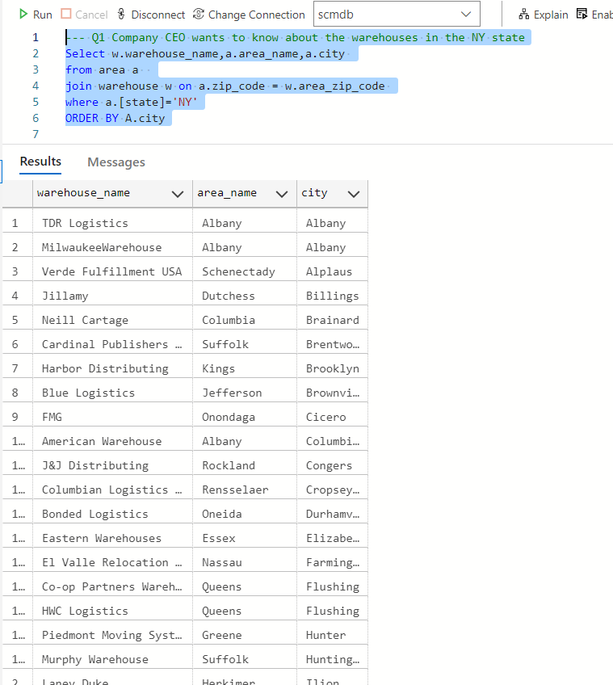

--- Q2 CEO IN NY WANTS TO KNOW ALL DIFFERENT TYPES OF ITEMS AVAILABLE IN NY STORES/SHOPS WITH THEIR QUANTITY

SELECT I.item_name,SUM(item_quantity) AS quantity, Avg(Cast(item_quantity as decimal(10,2))) as average_quantity

FROM items I JOIN (

SELECT sia.item_id,SIA.item_quantity FROM shops SH  JOIN shop_item_availability SIA ON SIA.shop_id=SH.shop_id

                        JOIN area a on sh.area_zip_code=a.zip_code

                        where a.[state]='NY') X ON I.item_id=X.item_id

                        GROUP BY I.item_name

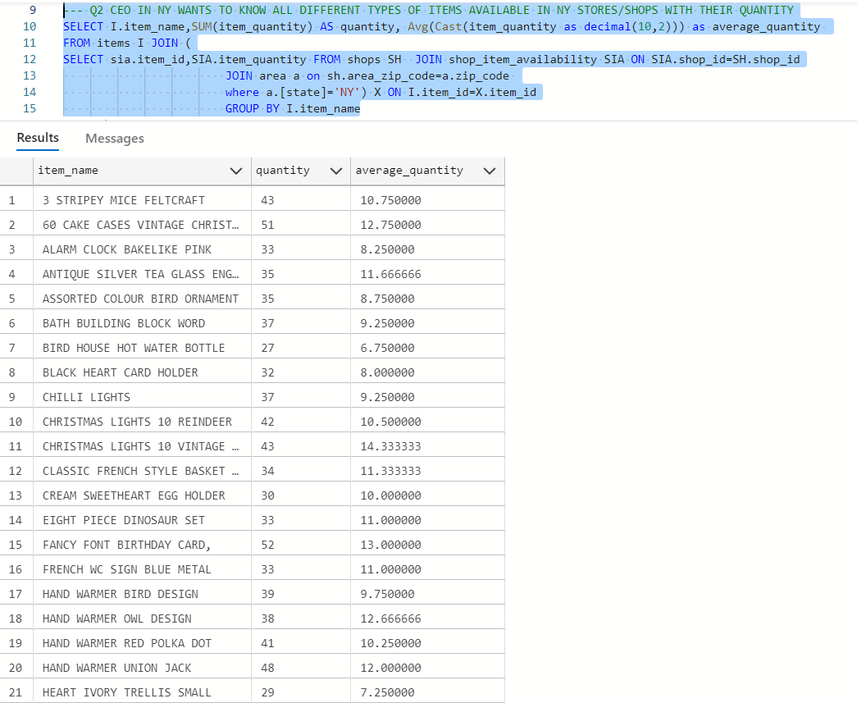

--- Q3)

--CEO WANTS TO UNDERSTAND WHICH ITEMS NEED TO RESTOCKED IN THE WAREHOUSE IN THE CITY OF BRONX

--THEREFORE, HE IS LOOKING FOR THE MINIMUM ITEMS WHICH NEED TO BE RESTOCKED. Look for all the items which have quanitity less than 5

-- and list the warehouses in which they are present.

SELECT I.item_name ,MIN(x.item_quantity) AS QuantityInWarehouse,X.warehouse_name

FROM items I JOIN (

SELECT sia.item_id,SIA.item_quantity,SH.warehouse_name FROM warehouse SH  JOIN warehouse_item_availability SIA ON SIA.warehouse_id=SH.warehouse_id

                        JOIN area a on sh.area_zip_code=a.zip_code

                        where a.[state]='NY') X ON I.item_id=X.item_id and x.item_quantity<6

                        GROUP BY I.item_name,X.warehouse_name

                        ORDER BY QuantityInWarehouse

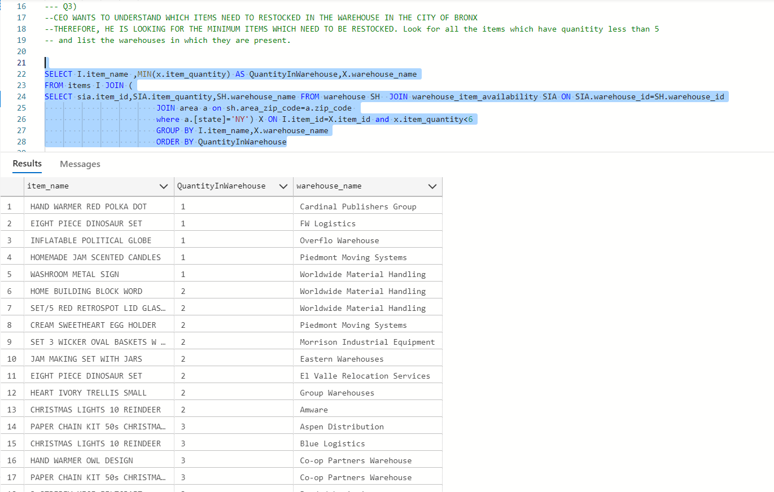

---Q4)

--- Supply chain manager wants to understand if the quantity of items in the stores is more than the warehouse.

select * from (

select i.item_name,sum(sia.item_quantity) as store_sum from shop_item_availability sia join items I

on sia.item_id =i.item_id GROUP by i.item_name) y

 join (

SELECT w.item_name,sum(wia.item_quantity) as warehouse_sum from items w join warehouse_item_availability wia on w.item_id=wia.item_id

group by w.item_name) z ON

y.item_name=z.item_name

 and warehouse_sum<store_sum

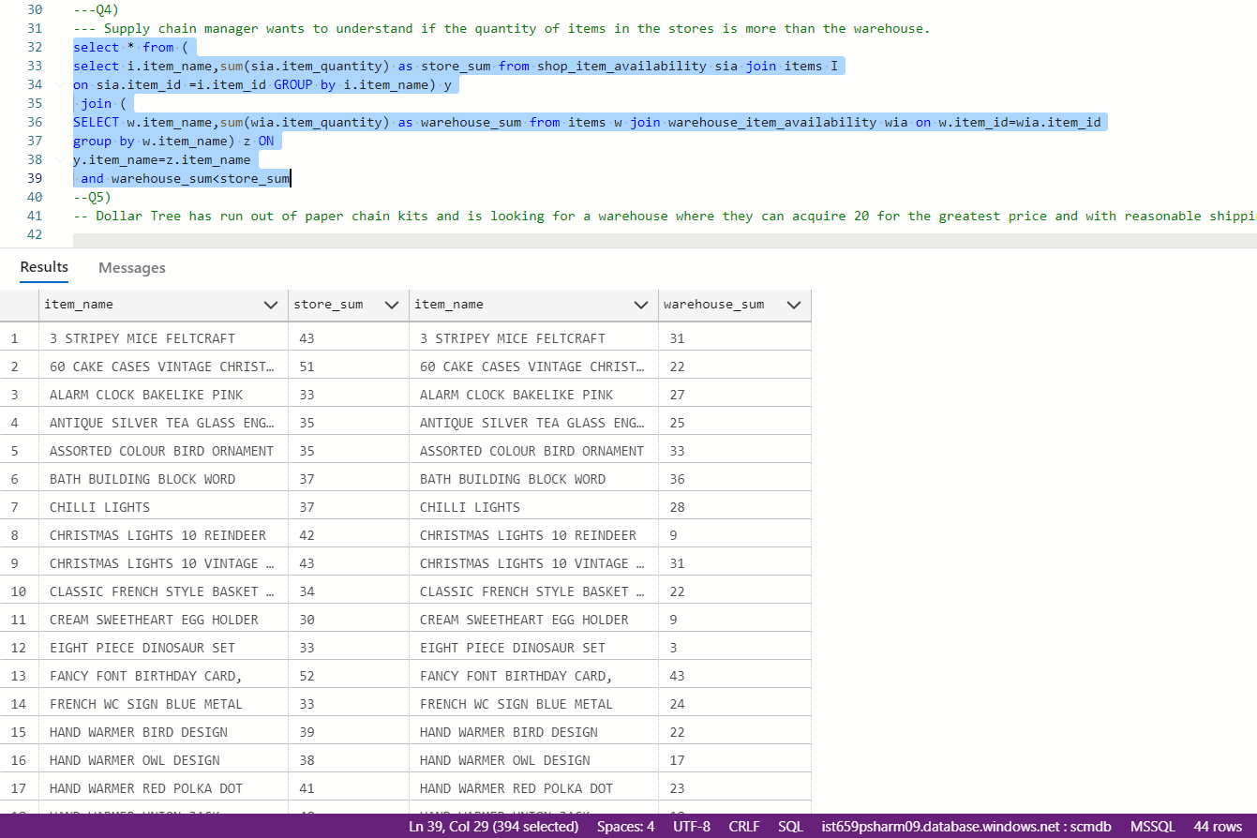

--Q5)

-- Dollar Tree has run out of paper chain kits and is looking for a warehouse where they can acquire 20 for the greatest price and with reasonable shipping.

GO

CREATE VIEW view_warehouse_item as

    SELECT w.warehouse_name, i.item_name, t.item_quantity

        from warehouse w

            left join warehouse_item_availability t on w.warehouse_id = t.warehouse_id

            left join items i on t.item_id = i.item_id

GO

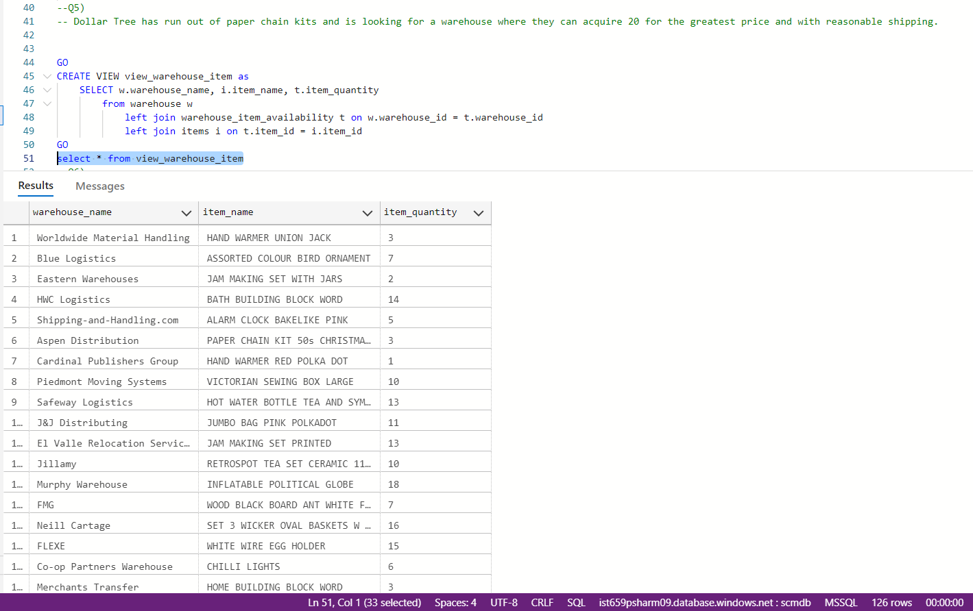

--Q6)

-- Shannon wants to know the item names and quantity of items present in a store.

-- We have created views joining the stores table, item availability table and items table and added a screen to the app, from where we can get the list of items and

-- quantities of them. Also, added a search bar to search the view with shop name or item name.

GO

CREATE VIEW view_store_item as

    SELECT s.shop_name, i.item_name, t.item_quantity

        from shops s

            left join shop_item_availability t on s.shop_id = t.shop_id

            left join items i on t.item_id = i.item_id

        where s.shop_name = 'Bargain Hunt'

GO

